REUSE

In many development projects there are heritage buildings or assets in the project vicinity. It is always challenging to know if these are worthy of keeping or removing. If they can be re-used and add value to the project and to build social capital for local community.
In an increasingly globalized urbanization project, it become critical to keep local identity and history. Not only do these unifying memories and structures define a community reuse and repurpose can ad tourism value.

In the endeavor to reuse many heritage buildings have been damaged by inappropriate use of modern materials. The weight of concrete extensions and structures can exacerbate damage in an earthquake or flood leading to greater damage and even deaths.

Victoria Pearce has extensive experience in the planning and reuse of built assets and in the stakeholder engagement to determine best use of these assets to harmonize a community and build social capital.

Heritage buildings have lived and lasted hundreds of years and there is a growing body of research about the building materials and modes of construction when utilized in new builds can enhance the viability and life span of a building. This is the best news for a community.

In the project scope we can monitor and advise on
- proximity vibration impacts
- Use of suitable materials
- Historic integrity of the original
- Archeological evidence
- Presence of lead paint, arsenic and mercury sulphide in historic wall murals creating life threatening risks for project staff.
- Insect treatment and management plans
- Corrosion abatement
- Identification of asbestos
- Mold treatment during treatment
- Conservation management plans
- Disaster planning and risk mitigation for the heritage and community.

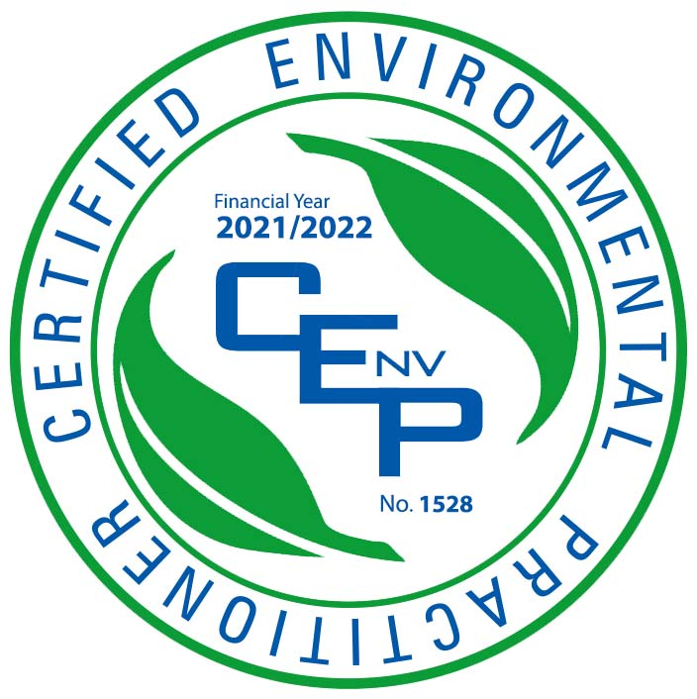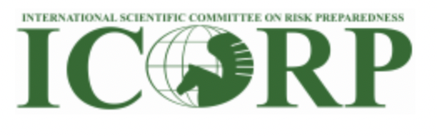l